**ALM for Client**

1. **Double click on it**

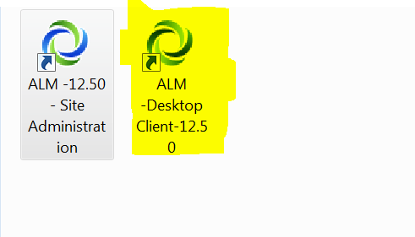

1. **user name: alm12, Password: alm12 then click authenticate**

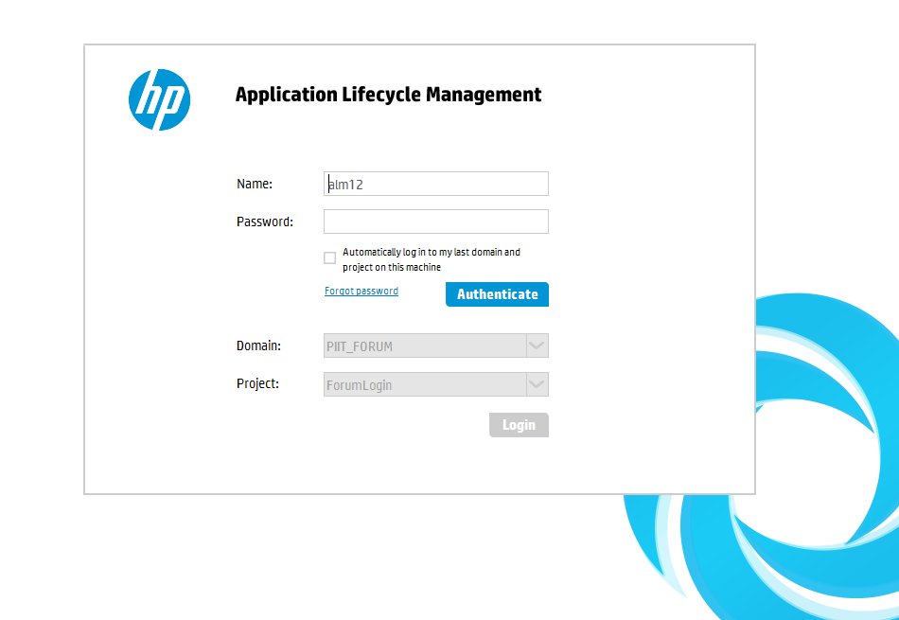

1. **select your domain and project**

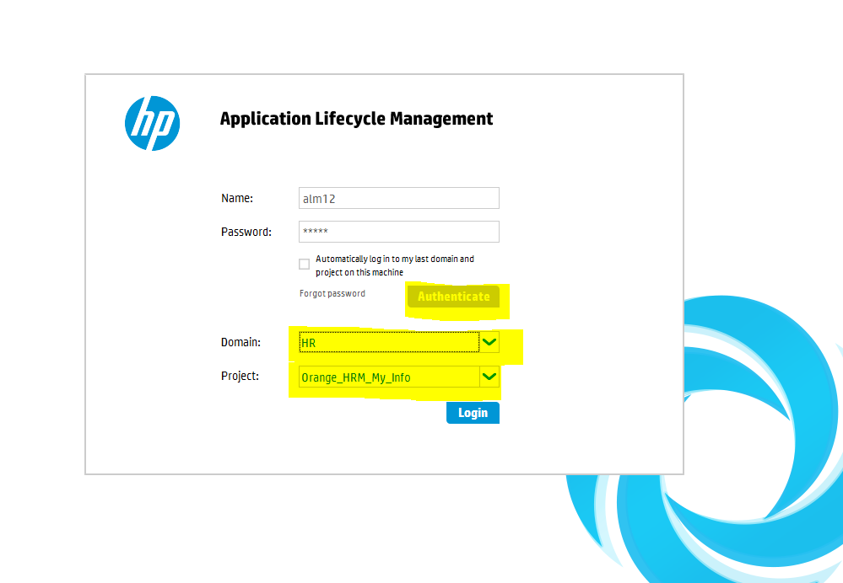

1. **You should be able to see user interface**

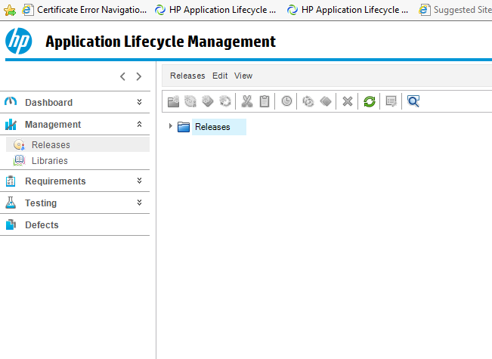

1. **You can see the domain name, project name and username you are signed in with**

**And this top section is called MASTHEAD**

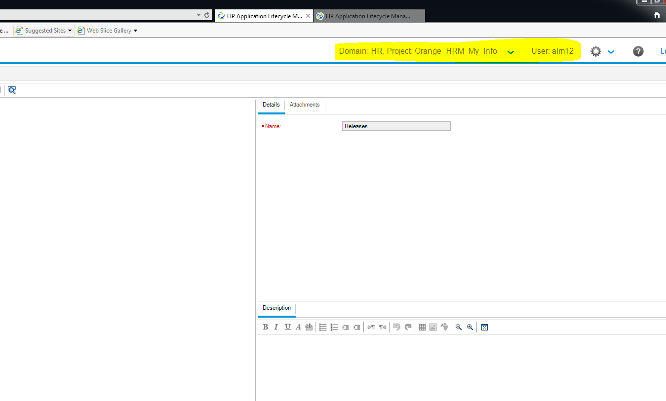

1. **Dashboard module is usually used by project manager, client or business analyst to check the graphical view of the project, how many defects there are, how much time left, how many requirements are covered.**

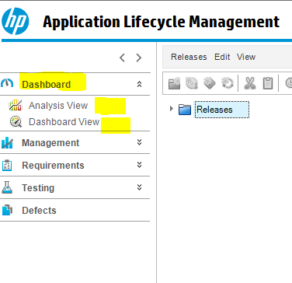

**7-Management module has releases where you can add releases and cycles**

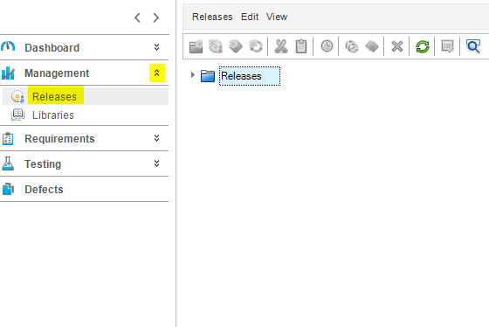

1. **You can add a release folder related to the project where you can enter your releases**

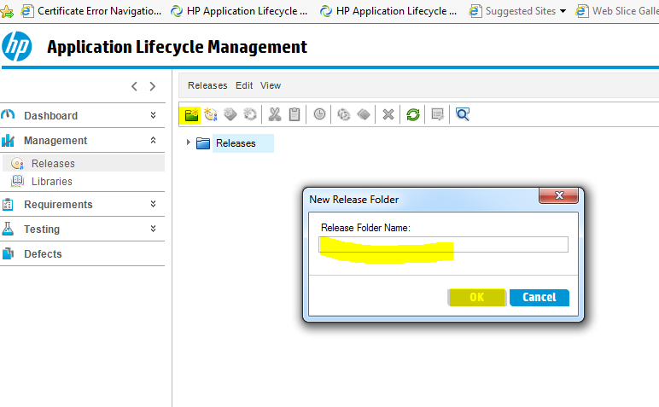

1. **After Creating the Release folder, you can start creating releases in that folder for that project**

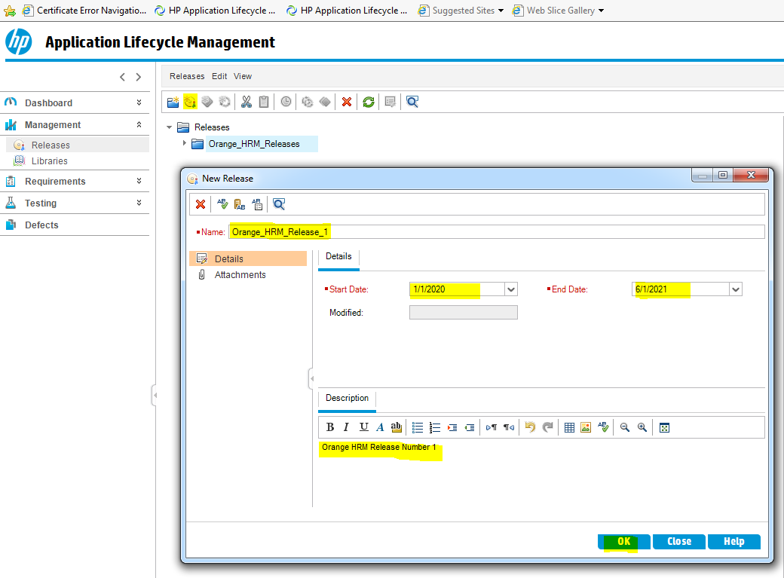

1. **Then you can click on attachments and add attachments, description or delete attachments**

